Lang Chain Prompts
17.06.2025

Prompts
Prompts are the input instructions /queries given to a model to guide its output.
Prompt can be text based or multimodal prompts like image / sound / video.

Static Vs Dynamic Prompts
Static prompt where users need to give an input every time with a change of words . But that change may be like that even an incorrect word would change the whole input by LLM. More inaccuracy like this would cause the LLM to predict worse and that’s why we use dynamic prompts.
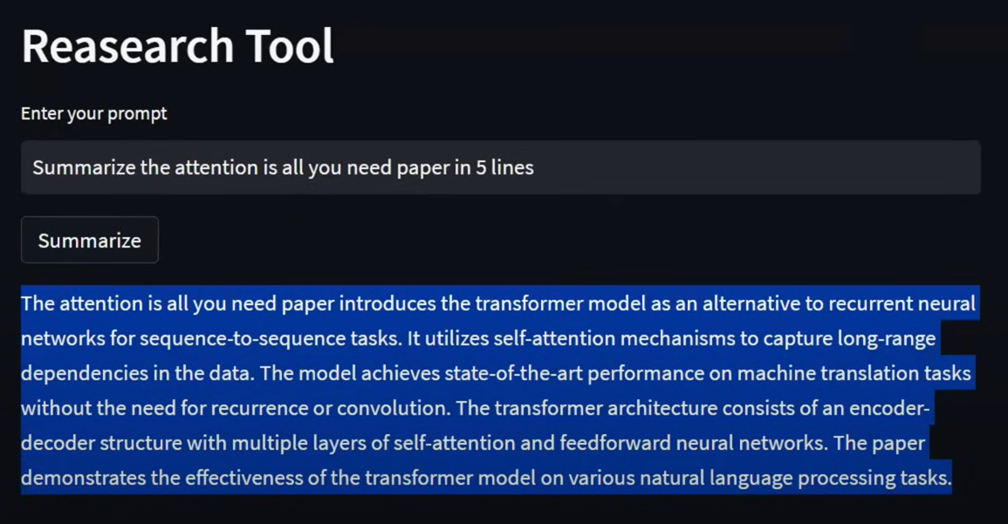

Dynamic Prompts use a prompt Template. Benefit of using Prompt Template is :
- Default validation
- Reusable
- LangChain Ecosystem
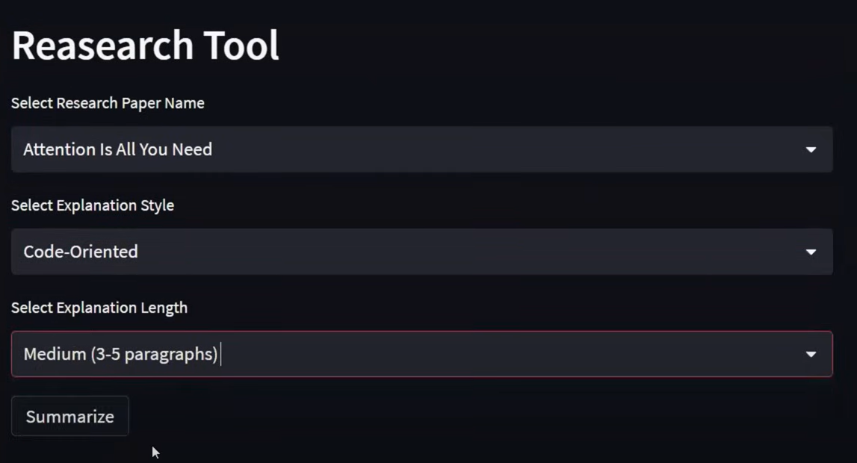

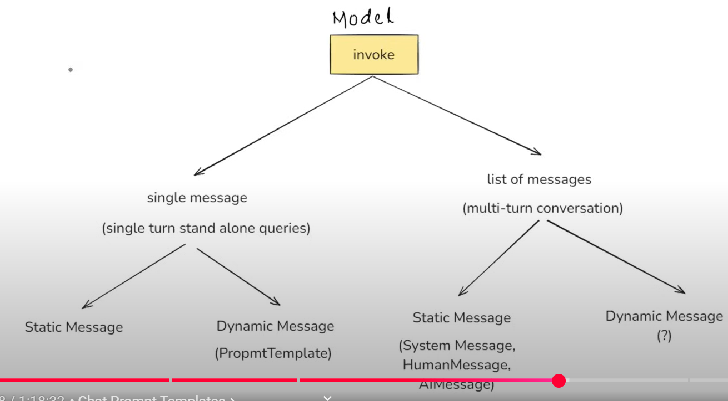
Chat Prompt Templates

In Multi Turn conversations i.e. a chatbot , Static messages chat history are maintained using System Message , Human Message , AI Message.

Now for Dynamic messages we have Chat Prompt Template which uses a Message Placeholder in langchain to dynamically insert chat history or a list of messages at runtime.
E.g. if you had talked with AI on a topic 2 days before, it stores the data in the dataset and retrieves it at the time of conversation at runtime using a message placeholder.

